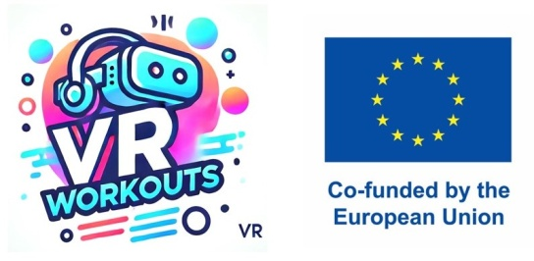

**Survey: Evaluating VR Hardware & Software Compatibility in Institutions**

**Project Name: Improving Physical Coordination in Children with Special Needs through VR Workouts**

**Purpose:**

This survey is designed to collect information from institutions (schools, therapy centers, SEN organizations, rehabilitation clinics) about their existing VR infrastructure, technology readiness, and potential compatibility for implementing VR workouts aimed at improving physical coordination in children with special needs.

**Section 1: Institution Profile**

1. Institution Name: Center for Autism
2. Country & City: Rijeka, Croatia
3. Type of Institution:  
   ( ) Special Education School  
   ( ) Mainstream School with SEN Programs  
   ( ) Therapy / Rehabilitation Center  
   ( ) University / Research Center  
   ( ) Other (please specify):
4. Age Group of SEN Students Served:  
   ( ) Early Childhood (3-6 years)  
   ( ) Primary School (7-12 years)  
   ( ) Secondary School (13-18 years)  
   ( ) Adults (18+)

**Section 2: Current Use of VR Technology**

1. Does your institution currently use VR technology?  
   ( ) Yes  
   ( ) No  
   ( ) In Planning Phase
2. Purpose of VR Usage (if applicable):  
   (Check all that apply)  
   [ ] Therapy / Rehabilitation  
   [ ] Physical Activity or Exercise  
   [ ] Classroom Learning  
   [ ] Motor Skill Development  
   [ ] Cognitive or Sensory Training  
   [ ] Other (please specify):
3. Types of VR Hardware Available:  
   (Check all that apply)  
   [ ] Oculus / Meta Quest  
   [ ] HTC Vive  
   [ ] PlayStation VR  
   [ ] Pico VR  
   [ ] VR-compatible mobile devices  
   [ ] Motion Tracking Sensors  
   [ ] Haptic Devices / Wearables  
   [ ] None  
   [ ] Other (please specify): Class VR

**Section 3: Technical Specifications & Compatibility**

1. VR Device Setup:  
   ( ) Standalone (no PC required)  
   ( ) PC-based VR  
   ( ) Mobile VR  
   ( ) Mixed setups
2. Available Space for VR Workouts:  
   ( ) Dedicated VR Room  
   ( ) Shared Classroom Space  
   ( ) Open Physical Therapy Area  
   ( ) Limited Space  
   ( ) Other (please specify):
3. Internet & Network Infrastructure:  
   ( ) Stable High-Speed WiFi  
   ( ) Wired LAN Available  
   ( ) Limited Connectivity  
   ( ) No Network for VR Use

**Section 4: Software & Content**

1. VR Applications Currently in Use (if any):  
   (Please list names or types)

Purchase of licenses by Carnet Class VR+

1. Are you open to adopting new VR workout content for motor skill development in SEN students?  
   ( ) Yes  
   ( ) Maybe, depending on compatibility  
   ( ) No
2. Preferred Software Platforms:  
   [ ] Android / Google Play  
   [ ] Meta Quest Store  
   [ ] Steam VR  
   [ ] Custom PC Applications  
   [ ] Web-based VR  
   [ ] No preference

**Section 5: Challenges & Support Needs**

1. What are your biggest challenges with VR implementation?  
   (Check all that apply)  
   [ ] High Equipment Cost  
   [ ] Lack of Technical Expertise  
   [ ] Limited Space  
   [ ] Student Safety Concerns  
   [ ] Accessibility & SEN Adaptations  
   [ ] Software Compatibility  
   [ ] Content not suitable for SEN  
   [ ] Other (please specify):
2. What support would help you adopt VR workouts for SEN students?  
   (Check all that apply)  
   [ ] Funding / Grants  
   [ ] Training for Staff  
   [ ] Technical Support  
   [ ] Ready-to-use VR Workout Programs  
   [ ] Customizable SEN-friendly Content  
   [ ] Equipment Recommendations  
   [ ] Other (please specify):

**Section 6: Additional Comments or Suggestions**

(Free Text Response)

We use them every day in our work on Computer Science classes. Students on the Autism spectrum accept this technology very easily. Class Vr has high-quality learning, device, and educational content.