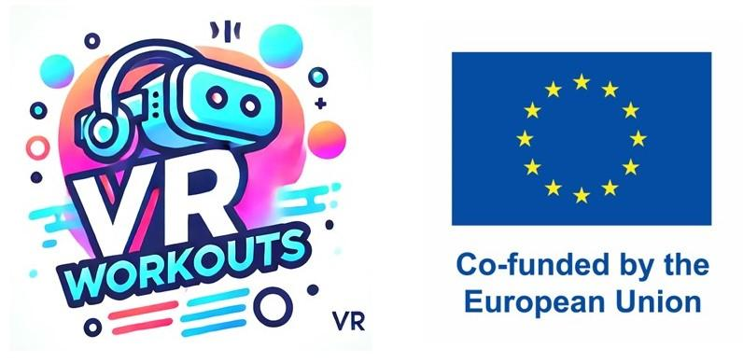

**Template for Exploring Physical Activity & VR Technology for SEN Students across Partners’ Countries**

**Partner Name:** Center for Autism, Rijeka **Date:** 2 June 2025

**Country:** Croatia

**National or Regional Curriculum / Framework Name:** Curriculum for the Subject of Physical and Health Education for Elementary Schools and High Schools in the Republic of Croatia

**Developed / Published By:** (Ministry of Education / Health / PE Authority / SEN Department)

**Focus on SEN Students in Physical Activity**

**Objectives:**

* What are the physical education or motor development goals for SEN students in this country?

The PE course enables students to get to know their body, its functioning, advantages and limitations, to understand the importance of lifelong physical exercise for preserving and improving health. The TZK course encourages harmonious growth and development of the body and proper body posture, contributes to greater work abilities, success in learning and personal and social development.

**Physical Activities / Practices Used:**

* What type of exercises, games, or strategies are commonly included?

Elementary exercises for the acquisition of motor literacy. Students use the acquired knowledge and skills on a daily basis in physical activities, which has a significant impact on actively spending free time, raising the overall quality of life and improving health. Special attention is paid to pupils with special needs in order to direct them to sports and other programmed physical activities appropriate to them.

* Are there structured guidelines for improving coordination, balance, strength, or flexibility in SEN students?

For pupils with special needs, knowledge and skills are particularly important in order to direct them to sports and other activities appropriate to them, which contribute to: the development and maintenance of working capacity, the fulfilment of school obligations, and respect for the rules and respect for diversity. At the same time, this subject area is directed towards the preservation of the locomotor system by applying the learned specific motor and kinesiotherapy exercises.

**Adaptations & Inclusion Strategies:**

* How is the curriculum modified for children with disabilities or coordination difficulties?

In order to improve the motor achievements of pupils with disabilities in the subject area of PE, they are: trained in simple physical exercise, to recognize the usefulness of breaks during work and study; to recognize and raise awareness of the need for the correct alternation of work in relation to the time of exercise; the application of natural forms of movement in everyday life and work, the application of what has been learned in the chosen sport and recreational activities, Ability to apply what they have learned in exercise, to develop a positive attitude towards physical exercise and to adopt and monitor health, hygiene, environmental and daily physical exercise habits.

* Are there assistive tools or differentiated instruction methods used?

This subject area is focused on the optimal training of students with special needs. In teaching and learning, it starts from an approach to accepting the uniqueness of each student during teaching, learning, behavior, evaluation. Only with a variable, i.e. individual approach to learning and teaching, can students achieve positive outcomes. For pupils with special educational needs (pupils with disabilities and gifted pupils), teachers plan a student-centred curriculum. The peculiarities of students require differentiated procedures, learning goals, the level of achievement of educational outcomes, the scope and depth of learning content, teaching strategies and activities that aim to achieve the set goals, and ways of evaluating the achieved achievements. This once again confirms that students develop and progress in a variety of ways. In a broader sense, only this way of learning and teaching can significantly optimize the overall biological, psychological and social development of students. At the same time, quality interpersonal relationships, fair play, social inclusion, critical and creative thinking, making the right decisions, solving situational problems, accepting diversity, self-actualization, self-identification, self-concept, teamwork, should be an integral part of learning and teaching. In accordance with the above, guided by the acceptance of individual differences, it is necessary to emphasize the active role of students through the ways of learning and teaching and connect it with life experiences. The TZK course itself clearly opens up the encouragement of complex forms of thinking in relations of cooperation and competition with motivation and challenges.

**Use of VR or Emerging Technologies in Physical Activity**

**VR Adoption Status:**

* Is VR or similar technology integrated into PE, therapy, or SEN programs?  
  (Yes / No / Emerging / Pilot projects)

No it isn’t.

**Examples of VR Use (If Any):**

* Specific programs, apps, or initiatives using VR for physical activity or motor skills development.

The Class Vr platform has programs available for every subject.

**Benefits / Challenges of VR Adoption:**

* What benefits or challenges are mentioned in using VR for SEN physical education?

Some students simply refuse this way of education due to sensory hypersensitivity or it is simply necessary to teach them how to control remotely.

The advantage is a camera that can be connected to the device and detects movements.

**Relevance to Our VR Workout Project**

**Potential Ideas for VR Workout Design:**

* Activities or methods from this curriculum that could be adapted into VR.

Simple motor games, motor games with elements of walking, running, hopping, jumping, throwing, catching, climbing and descending, crawling, rolling, skipping, crawling, falling, simpler hiking tours, snow games, games in the water, on the water and by the water, orienteering games...

* VR features that could improve accessibility, motivation, or engagement for SEN students.

Accessibility and motivation because it is a new technology for them, they keep the focus on the task at hand because there are no other stimuli.

**Gaps or possibilities for VR integration:**

* Where could VR fill existing gaps in physical education for SEN students?

In physical activities that are difficult to access or inaccessible for material, technical or safety reasons: skiing, diving, high jump...

* What unique needs or cultural aspects should be considered for this country?

Weaker material position of education, teachers and material conditions in Croatian schools.