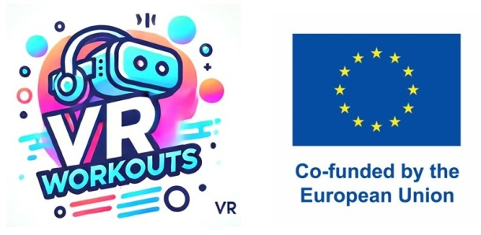

**Interview Questions for SEN Students**

**Introduction:**

Hello! We’d love to ask you some questions about how you like to move, play, and learn new things — and what you think about games that use Virtual Reality (VR). There are no right or wrong answers — just say what you feel!

**About You**

1. What kinds of games or activities do you like to play?  
   (Example: dancing, ball games, running, puzzles)
2. What is easy for you to do when you move your body?  
   (Example: jumping, balancing, walking, stretching)
3. What is a little bit tricky or hard for you to do when you move?  
   (Example: catching, balancing, running fast)

**About Moving & Playing with Games**

1. Have you ever played with VR (Virtual Reality) before?  
   (Like wearing cool glasses or headsets that show you a game world) (Yes/No)
2. Would you like to try fun games that help you move better? (Yes/No)
3. What would make a game fun for you?  
   (Examples: bright colours, music, friendly voices, prizes, animals, dancing, jumping)
4. What things would you *not* like in a game?  
   (Example: too loud, too hard, scary sounds, too fast)

**About Feeling Good While Playing**

1. What helps you feel happy and safe when playing games or doing exercises?
2. What kind of game would you like most to help you move better?  
   (Example: dancing game, adventure game, animal game)
3. Is there anything else you want to tell us to make VR games better for kids?